**2025-05-06 15:06:08**

Yeah. Phenomenon. All right. soWe need to start at the very tippy top of avr and then let's start fanning out all the questions we need answered to figure out who's going to be helping with what pieces and parts.

I don't even have a tab for this yet. Ii have a tab that's called big projects. And right now send us maybe our particles. umLet me pull up the, umand I don't know this is necessarily fully supported the service list that we had before.

UmThink that does um gives us some of our big activities, right? yeahIt's picture. There's, I don't know if we need to worry about the systematic components or do we need to think about processes and technology, right?

andSo I think we start with, so the technology we need to figure out the requirements for our technology pieces that include everything from credentials to the retrieval, to dashboards to all of that. Right? I think one of the things that we don't necessarily have in here, i've had some contemplation of, but not really gotten into a good place where it is.

We need a way for clients to provide us with credentials. however theyHowever, they have their stuff mhm that then we can move through the system, because one of the problems that we have loading perspective, just as well, is sort of there's all this transformation that occurs, but you don't necessarily have any way. There's no place to keep track of it, because a lot of stuff's happening in excel.

And I don't know if that's too far back or not. No, I think it is I think it's okay. But question, yeahare we talking about individual credentials or large scale credentials? Like a large volume? I think in that case, we're talking about implementation size, credential lists, sort of larger.

That's what premiere is doing. So we've got that process. Now. What I need from a technology standpoint is a way to get out of the spreadsheet process. I dealt with them, but it's effective right now.

And dean stopped by earlier today. Dean was stopped by me and asked who and I said andrea, yeahand he says that they've spun up a very simple user interface. So he's gonna set up a meeting with me. I'm gonna walk through that with him.

We might expand that and see if I can utilize whatever he's done instead of access database. So I think there's 2 pieces that I think we we need that credential scrubbing. And I think there's layers of that.

And so that's not for this. We can go through all those level of details of what that is doing, what it needs to do, what can it do. But I also think that from a technology standpoint, we need the ability within within a one of client portal like an expense mark for them to go.

heyI have a credential for this and even somehow get it right to. So we need a connection between vcm and a client portal. and andIn my mind, the thethe tricky piece, or at least the piece that the client could do in that space, especially with one account, is this is the account or the site address, whichever because it's the connection of the account information or the login information to the account information.

Because that's the seems to be the complexity is the account matching part of it. So we circumvent the account matching. I am able to say here is if it is, so here is the account I am looking for. Put this information to that.

andThere's not a lot of information you need to provide. It's just the username password if there's a registered email, although I think we I want to get away from living, at least that was martin was like we need to get get that away. That is where getting away from the client so right now.

In the vcm we're not changing the registered emails. We're logging what it is, because i'm leaving that for a downstream process, right? Right? Because right now, if weif we are going to go through arcadia or even a future state, and we need it redirected to us, we do, we'll do it in anotherwe'll do it in another way.

yesI don't want them right now. I don't want them stopping what they're doing to wait to to change it and do a validate the connect like, I don't want that slowing that process down for now. So what i'm hearing is that we need sort of sort of group credential, intake and yeah individual, yes.

And its intake of on with there's also a validation piece to it. yeah soAt the group level, we are were validating them, were inventoring whats on the credential. andWe're inventory it against what is loaded today.

So what we have loaded during the implementation phase, soif i've got a credential with five logged, with five accounts, do I have four loaded? wellThere's one that's discovered. They'll put that on a list for implementation to go back and figure out.

And I guess is that then become more. It's both, right? I think we need to focus on it being technology until we're told that a person has to do something, right? Because I think there is the notion that it's one thing.

I have the bot or the ai that's going and saying, go to this website, mhmlog in. It gives a successful log in whatever that means. But the next step is, then, are the all you knowis that account or there are other accounts on it and then getting access to a bill of some sort, because it was sort of that was like the three steps in that.

Yeah. So I mean part what what we also need is just a queue to kick out stuff that needs to be worked by human. yesI think I mean i've got lots of different functional ideas about how that could work but without knowing what we're starting from.

you knowLike, okay herehere's a credential. I'm gonna tie it to to this vendor that those credentials tied to this vendor. I'm gonna list the accounts, right? and thenMaybe you know it's doing some type of searching to find what's loaded on our system is going to bring back and link them.

But then you can add ones that are unlinked, right? And what does it do with unlinked accounts? Right? Maybe there's some type of grab a bill off that. And like so then it creates a workflow item that maybe high in the sky, because this is an implementation process.

Does it flow back to utility support to load it? There's also a client at opponent like it's it's messy it's messy and it's even more messy when i'm passing it back and forth and email right now. So I wanna do so.

I guess there there's a more detail i'm hearing. soThere's a more detailed sort of status option that we need to have, but you know because we have a queue of you know new verified, login gets verified at account gets verified. you knowBut then there's these other places of what do you do within.

We have to say, okay, I go here and I see a list of I can only map so many of them. Then I have another group that we might generate, which is a I don't know, an orphanan orphan review list or something, but it's just a different status that may not necessarily be aligned. andAll of that is is the functional aspect of getting the credentials into a platform that are usable for downstream.

But if i'm remembering martins conversation where I came in, he wanted to pull it back to even a bigger like where we've got vendor vendor intelligence and what the vendor can and cannot do. So that's where ii had a hard time. I'm like, okay, what's the purpose of this team?

Are we trying to do vendor intelligence gathering? Or am I trying to scrub credentials? Because I can do the we could do both. But that's going to slow down my my efficiency, and i'm going to need more people to get through a bigger list.

soThat's why I was like, what are we doing? Yeah, andand I think there's a need for certain there's all of the vendor intelligence. Right? But the things that are listed is do you have, is it one login per account?

Yeah. That's a status for them or is it a list? Is it you know how much bill history is available, which you may or not be able to tag from any given all login? But I think they probably I think they could get to something.

These are the kind of questions like, do we want them answering those questions yes or no? Right? It kind of going back. What are the list of questions? Right? Are we vendor intelligence questions or what I can effectively do on a website, because I feel like some of those are a little.

andI think they overlap to some degree as well right hand. well andAnd I think that we don't need all of them for the abr portion of it, as opposed to what we for missing bill or great. soWe probably need to develop the questions we want initially for abr because that's the hotter piece right now.

andIt's a smaller subset. And I think as we went through the list, I remember when you sent that list, the other things I had, as I started to go through what we had from the the the gap analysis, on thefrom the management system. I don't think there was really a lot of other stuff that was necessary for bill retrieval, because it ends up being leafy information.

What kind of payment there is under intelligence, yeaheven like how many how many months of history, you knowwe only care that the recent month is available. That's all we want to be able to find that it's in a pdf format, those sorts of pieces it's more about. Is it a login?

UmI think there is some question of what you do around. Some of the third party service pieces, like invoice, cloud and municipal uh municipal, yeahwhatever change that's putting in. Just because there's a couple, there's like three or four of those that exist that aren't necessarily log in.

I have that nice. yeahCould we pay a bill without? wellWe can, but I don't care if I can pay pay a bill without logging credentials that doesn't help us with the bill. andSo maybe that's where ii need help because maybe you guys know more than I do what is.

But some of the invoice cloud we can pull in an invoice. yesAnd that's the thing. And I think that's the difference is is that that question is where the uh what is todd hoping for us? So because I feel like this is this giant mom's share of a project, what is?

So we need to pray by the end of this month business requirements to get this program up and running. And that includes the technology pieces, but also our overall vision of it. And it may happen that an arcadia lookalike comes in and does some of this as well.

So we keep calling it it. we areWe are talking about like, how do we go and get an invoice in treatment? And you get it so that we can put it through codex and start through the process. soThe problem statement that we're solving for because I had a more upset with that that, right?

I think that's where i'm trying to get to is like, how can we solve it? we'reWe're solving to reduce incoming male, prioritizing the clients with lower on time percentages. So that is ultimately a problem.

I'm retrieving pds okay so there's, I find it interesting that there's no, well there will bethere will be like, okay there will beI just think he thinks there's a big enough buffer in there from what we're right now, that there will be an opportunity there there will be. yeahSo right now, we're moving forward with how do we support more on boarding with arcadia? yeahWe're not worrying about replacing arcadia.

umWe have to assume arcadia will be out of the picture for pdf so how do we build that technology ourselves? Yeah. soThis is potential. This is scheduling. This is downloading, and this is management.

Yeah, we should look at it, right? What did you say about it? Prudential downloading, scheduling, scheduling, yeah. And then the management piece of it, because that's where I think arcadia portal falls short, a little bit like management of like, what we're enrolling okay and management to me also includes what we're enrolling, what the status is are, what's bouncing out for a human to touch piece of that.

Because there's a lot of the arcadia sort of washes their hands with anything as soon as they sort of walk away from it. wellAnd it's really hard to go into arcadia and understand where everything is from a standard standpoint, too. Because they have 101 status is in the yearly.

But I know that it's one of the opportunities I saw when I was mapping. Before when I first started was they get a list of like, here's all the reason codes for why things didn't happen. mhmBut the follow up process for that is just beyond something that first alexi by herself through a spreadsheet process, even as you forward it to mars and stuff that just it it's untenable yeah with a tracking process.

I think that's the management piece that I see. The real opportunity is to close that gap 100%. okay so UhI think we chemistry, urban technology, but I think that's just because that's where we started, but maybe we should go in the chunks of it, because they're often intertwined at some.

, right? Credentials is really the big bucket that we have to solve for that leads into scheduling and downloading, leads into management. Well, and and Ii mentioned this to todd right now. I have two full time.

Employees are are part of the bpo they have done one of medium sized project, one tiny project, and i've got them now doing one slightly larger project. So they've done a project that was about under 50 credentials. They turned that around one day.

Mhm. But it was also only about five or six vendors, so it was easy for them to flip through them. Quick whack was about seven hundred eight hundred credentials, and it took him. Again, there was a learning curve.

It took him about 2 weeks. They're now working through an old file, petsmart, which is about 2,000 credentials. So I wanna see how long it takes them to do that. yeahAnd maybe we can get an idea of how much they can get through in an 8 hour day to figure out okay this is how much they can get through.

If ive got this many credentials, how longhow many resources do I need the other thing that, again, inin lack of anything better? My plan is is to set up like a team's channel with microsoft planner and I have cards for all the different projects. And so kind of like what one does with account loading is i'm gonna get i'm gonna start stacking up projects of size with delivery dates and hopefully trying to prioritize what do we need first?

What can I shove off? andThen if i've got stacking it up and i've got 15 projects, then I can go back to premiere going. Okay? I need yeah I need more resources, but some of that is I need to start going to the account manager everything like what do you got?

Yeah, who's got preempt? Like I went with petsmart was taught if you found those. And when I looked in vcm they only had 160 credentials in vcm and I had 2,000 on this file make. Once I figured out that stuff would fall out.

Great. Like okay so. I did that. So that's kind of my plan, but i'm going to start collecting them so that I can start building projects out. And then we can start prioritizing the based on size. Okay?

soUnless if people get better processes or technology on that, that's what i'm doing in the short term. At least I mean that I mean it sounds like you're absolutely great. Yeah. But I don't want to ask for more until i've got yeah yeah yeah, that the planner in place, so I can start building out the cards, because my point my hope is is that i'm gonna put it together, give them projects with due dates.

And then then they can just right work through them and see what deans built to see how that helps. Yes. soSo maybe we just start thinking about the whole potential stuff, because I mean according to martin, he's got scheduling and downloading.

I say that with a smirk, he had a pretty good. Doesn't consider the what ifs, though, and he has to. andHe's like, but laurie, we're not here for the what ifs is it, but the what ifs happen that then cause a human to intervene.

And I don't want to be intervening when a bill is now has been ready for 3 days, because then we should have just had it mailed. So because he doesn't think what arcadia does we should do, where they check every week. And then 7 days leading up to the due date or the bill date, the invoice date.

They start checking daily just to make sure potentials are working and nothing has changed, and the website hasn't changed, and the requirements haven't changed. I don't know what. I don't see how you can't do that.

he'sHe said, no, but he goes, we're just going to figure out the algorithm. And we're just going to check on the date of the bills to be ready. andThey said, what if we miss rebuild? What if we miss? you knowAnd that on that date it doesn't work and they've had ah they have a payment delay or billing delay or their power.

Yes. andThere's like 1 million things that could happen. I mean the rebuild example that you brought up is important because if we don't get that mid mid cycle bill, and it goes out and it hits the website, it's going to pull the next bill and it's going to have the rebuild and it's going to have a balance.

It's different. We don't understand. And it's going to create exception, which is going to create work. I explained that all to him. Ii know you did. andHe was like, we don't have to worry about that.

That has to be very rare occurrence. I said, no, it's not rare to the point that arcadia has built processes in place for. The other thing that we have to think about here. And I know in the short term, we are utilizing abpo we need to be sensitive to the fact that we are potentially giving away sensitive information to an outsourcing party.

Yeah andThere are going to be clients that are not going to be okay with that. So it could be that the bpo is the short term solution, but as soon as clients are getting wind that we are shipping their sensitive information overseas, we might have a problem on our acadia ships overseas today. We're just running into it more and more.

I know yeah that they are they do not gone out. That's right. Is it an accident? All right. andBecause some of these guys have got auto pay stuff that was pretty fancy. Sorry, I got distracted. And they could have credit card.

They could have banking information logged on these these credentials. It's scary. I totally agree. We'll have to solve for it. soBut I just wanna I mean going through the credential process as a bucket.

So we have the intake. We talked about sort of, he passed both group and individual cases. yeahSo when you talk about the process that you're sort of setting up, the premiere, is that a the are logging in and checking the credentials and that they get access to to a bill or what is there?

What is the scope of what they're doing? So right now, what i'm giving them at the beginning of a project, i'm giving them whatever file we get from the client. I'm not cleaning it up, i'm giving it to them.

Right? However, we get it, they're getting a current site cross reference file, so they know everything that has been loaded for that particular client. I'm giving them the po box for the client so that they can change addresses.

If they're capable. They get the shipper number of the client name, and they get the vc that not email that that melissa has set up. So I give them all those pieces. Because depending on what they can and cannot do, they may need those that information.

So they start with the login file and they go and they date when they touch a login, they attempt the login if it they immediately get a failure like they can't validate, they can't get in. They give me feedback of whatever they're getting from. That login is not valid or cannot access because of mfa so all they're doing is just giving me that within the login spreadsheet.

So i've got a comments column that they're giving me those types. So at the end of every week, I get login failures that i'm then sending to the client through the client account manager saying, send these to your clients have and try to resolve these these login failures. So there's a pass back there, right?

So future state, maybe there's a way for us to escalate those types of login failures, right? soThough they're going to attempt the crop, the credential, they're successful, they're gonna go in. they're gonnaThey're gonna find that vendor on the site cross reference file.

They're going to log that this vendor primary code, this vendor name, this login information. andThey're gonna use the accounts from the set cross reference file. Are those the same accounts that are over here in my login?

Yes or no? So if it's a 1 to 1, they're going to grab the account number from the site cross reference file, which is our account. Put it in the vcm upload template and move on. If they've got a list in the credential, like I said, maybe we've got five in the credential and i've only got four loaded.

They're going to say, hey, i've got a 5th account. They're gonna add it to the site crush reference file. Tell me that there's an account ad, and they're gonna give me whatever information they can get.

Or other way, heyi've got five accounts over here over here. There's five, but one of them says it's inactive, like it's a closed account. They're gonna tell me that that account is closed. soAgain, it's kind of doing some gap analysis during the implementation.

soI get that pass back piece as well on the ad or inactivate accounts. Um soValidated. They're going to attempt to change the address. They're going to attempt to take it off auto pay, and they're going to attempt to take it off e billing, regardless of whether the e billing is an emailed invoice or not, because you can't always tell how the vendor is going to send it.

So we're just taking it off and defaulting it paper until we can figure out the better solution. and thenThey're keeping track of what they're able to do. Are they able to change the address, take it off auto pay, or take it off ego.

They're giving me a yes or no, and they're defaulting to pay for only when that's an option, right? Because some vendors, if you go and log in, they automatically make you paperless. But that's telling you, yeahbut they're they're going through they're combing through the website, and they're looking for to take it off paperless.

They're removing that paperless option. So even if that does default them, they're turning it back off before they come out. okay yes okaySo change addresses. so yeahSo in the vcm I will they're giving me the vcm upload inside the vcm upload.

I'm getting a yes or no of what they were able to do for those credentials for that specific account. They're mapping it out so that it's importable as soon as they give me the product, the project, because they're mapping it to the right accounts that we have loaded. In some situations.

If they've got some discrepancies, they've got cast utility access because they're through avdi so they can go and check. Hey, I see an account number in the credential, but I don't see it on the cross reference file. They're checking cast utility.

Can they find it by the service address? Or can they find that account number? If they can find it? they'reThey're adding it to the vcm and moving on, because ive explained to them. Sometimes there's a timing component with when I send you the site crush reference file.

So they at least have a a working knowledge there. If they can't find it in cass utility, then they're adding it over here um so weekly weekly. I'm getting the login issues. I'm getting a file of any login issues, and i'm getting

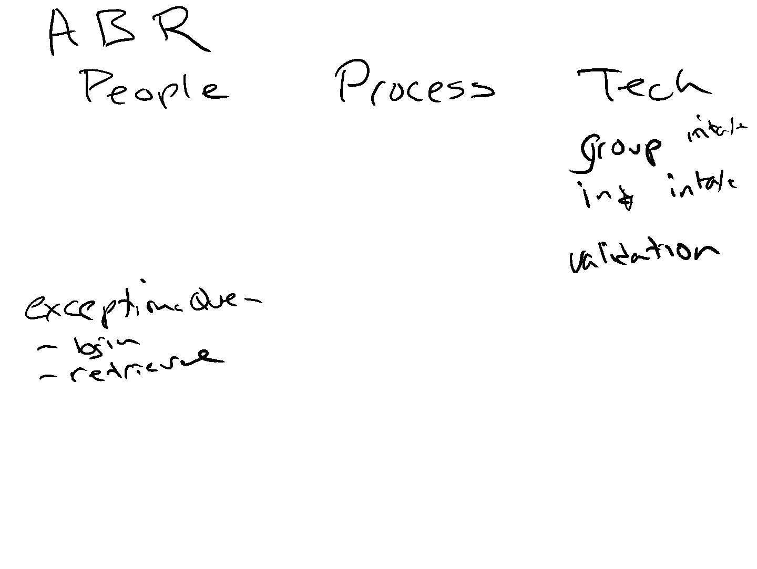

So every week, I know how much they've gotten through. I have two touch bases with them a week on monday nights and wednesday nights. Eight thirty eight thirty eight thirty. umIt's taking us about 10 minutes because they don't they'll usually send me the questions at the end of their day.

Perfect. soI at least know if they've got anything that they want to talk about. And rebecca is also sending me the file. soI can at least see what they've accomplished in the last few days. So I have a pretty good idea of what they're getting through.

So that's what they're doing. Today. Are they verify verifying in this pdf? No. I'm not asking that of them right now. So at the conclusion of a project, they send me back the vcm upload. They send me back a site cross reference file, telling me this is add, this is an inactivate.

We found this account. What they are not doing is they're not going the other way right now. So if I have an account on a site press reference file, but I have no credential, they are not attempting to create credentials.

I haven't we're not going that way yet. So I get the cypress reference file. I get vcm upload side, crest reference file, full login failure, issue list, and the login file that the client gave me back with a date of when they checked everything.

So those are four deliverable as I get back at the end of every project. So the vcm template, the site cross reference, the client login annotation, and then the issue. So there it's the same information, sothe client login file there.

theyThey dated it. And they've given me comments and any comments where they failed to validate that credential, living out into a separate file that I send to the client. So it would be nice to see what dean has created to see how yeah because i'll pass, there's a lot of stuff that we're passing around.

Yeah andEven the deliverable that are coming back. There's pieces that i'm peeling on and handing to other people to do some stuff. I don't there's not a better process right now, yeah of coursenot short of a technology solution.

So it's tracking it is gonna that's where i'm like the planner will help me because I can notate you the different things. Do we imagine that this process will some sort of third party is so as through what so like through like me or something? No, I think everything's on the table is an option.

I mean I it just I don't know it would be there might be some. I think we have it is definitely going to be more expensive to have it in house. I'm paying 950 an hour, so I think we need it the option to have it in house.

I mean like, if there's a client in the contract that says you absolutely cannot out source that no, when I think about the other part of it to the escalation process component, some of that that back and forth, not necessarily be like a full ftd working activity. wellI arcadia today, offshore is most of this, and then their escalations are in house, in the management of that team. Of course, it is um okay so the gaffe that I hear.

Space is just the validation. So we want them to determine whether the download image is apdf that won't that that? Because at the moment, so there's there be ah you would need we'd need a different process to be able to pull like all the it is you can it's a viewable invoice, but it's not a pdf invoice.

There would be a thing from a technology perspective. wellI think seeing deans interface that that would be something that would be very easy for them just to check a box to do.

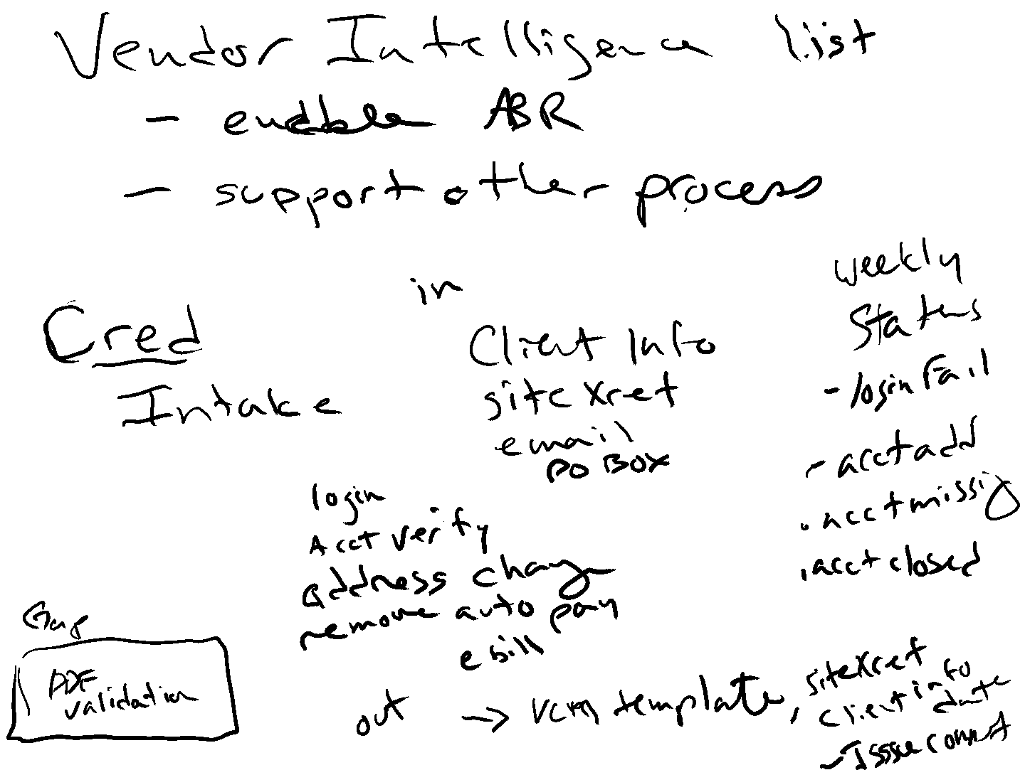

Other than and this is more on the technology side that the pdf is available for the account. The next piece is just that we have this month's bill. That's not a useful solution. Scheduler process would be.

So I don't try to think about there's any other intake startup company. I think is well just it's just, I guess the current state is are the one who handles the client escalation? Is that the end desire or right now in a perfect world, right?

That's what we're aiming for, right? Perfect world. mhmI am getting this project to them will say, ideally, 2 to 3 weeks before go lie. Because in my mind, for thefor the vast majority of clients that we're gonna stand up, that i'm i'm hoping to get to a point where they can get these credentials cleaned up in a project done and turn around and and more days.

That's my goal. soThat way, write it, write around, go, live, maybe a little before. I've got feedback. And then we can go to the client and work through. heyWe found these accounts. Are these valid? Do you want us to load them yes or no?

heyWe've got these inactive accounts that according to the vendor website, you're good in activating you know all or hey we've got a list of login failures. You can resolve these and send them back to us. We can finish this and get like, so we've got these little pieces.

It's going to be part of the implementation team. So the timing of it may be whether it's the project coordinator or whether it's the transition specialist that's gonna own this, but it's all going to stay within that implementation. Yeah, the account manager isn't going to come in the new state.

The account manager doesn't really come into owning anything until we get into a steady state, which is ideally eight to 12 weeks after go live. So all of this is going to be either project coordinator or the transition specialist is going to own that. But if we've got existing clients, let's say we've got and even in a future state, if we're adding a bunch of new business, adding phases, that in the future state is still staying with implementation, because I want them managing all of the add on business, because they know how to do it and get it stood up.

So that's where, again, that transition specialist knows all these moving pieces and those processes. They're the subject matter expert. So unless we get an existing client going, heywe found this right, massive file of credentials that I didn't know we had, then it might be the account manager, but that's going to be a rare scenario.

But it could be more often now, as we were trying to do clean up, i'm trying to think about it from the standpoint. I guess we have account ads as they sort of partial implementation or they had an acquisition or something like that that. I want that all going back to the implementation scheme.

Yeah andI've told brian that that the project coordinators, we need to get to a point where the project coordinators are going to handle account loads, all that kind of stuff for phased on boarding acquisitions, all that stuff, because it keeps that they they understand the process, especially as we move to the account loading new stuff. They are going to know it. They need all of that moving to them.

andI've explained this to brown like, right now, you guys have the bandwidth. If we get to the point where pete's out selling, like crazy again, and you guys are getting unicorn, right, then I get then i've got it all running through you guys. Now i've got numbers to show, talk and look, the volume is there.

I need I need more project coordinators to facilitate all of this. It doesn't need to live with the account managers, because quite frankly, they do it so infrequently, they don't do it. Well. So putting it back with people know who how to do it ensures that we have consistency, done, right?

And done on time. I'm just trying to think about think about existing client login clean, I guess at the current state. Maybe that's still. So like right now, pet smart is the project they're working on.

andThat's an evil. No, I mean that that that client is in a steady state, so I would probably send that back to the account manager. But I that's where it's it's gonna get. It's gonna be great. It's very great.

And even then it's gonna be like, hey, we found this login credential file. You sent us 2 years ago. We're finally doing some what so i'm going to tread lately a little bit there, and we'll see what comes back with it, because like they gave me some feedback, I talked to them on monday.

They had a whole host of aep energy log ins, where that that one was, they weren't working, but other ones were, they said the service wasn't available. We'll just try it again tomorrow and see if they come back online. Yeah.

So I think the gap, and I said it is were going this way were were taking what they're giving us and making sure what they gave us matches what we have. But they're capable of creating credentials. Right?

So and I think we need more vendor intelligence before we maybe figure that part out. And is it the same team? Is it the same project? I don't know, because

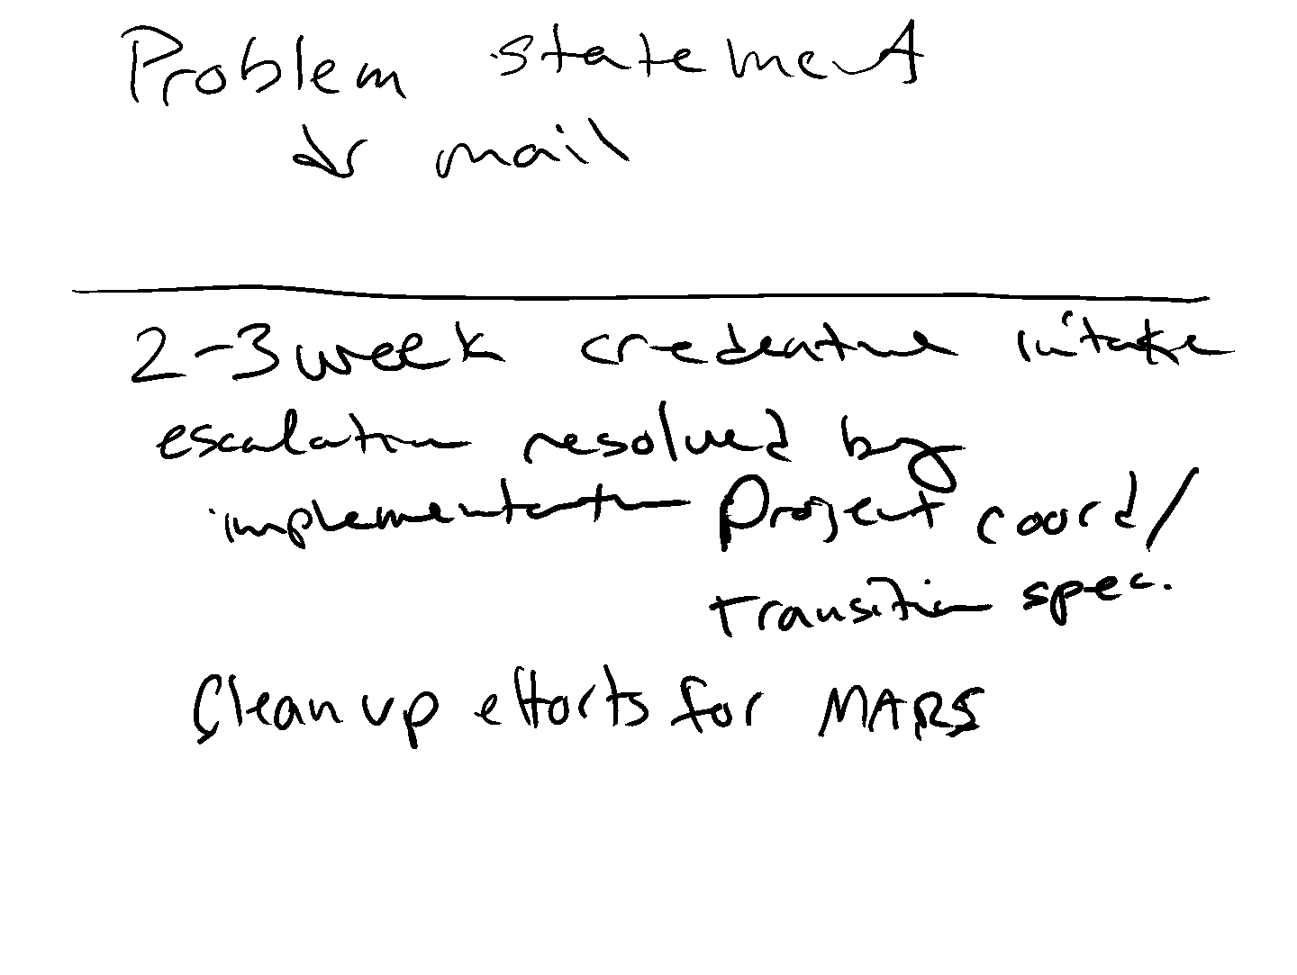

Do we know do we have websites associated with those vendors that known vendors? And can we send them out to create currently some of these vendors may have websites, but can we create credentials? what's theWhat's the information available?

can we doCan we add lots of log ins to one log one credential? Or is it 11 per? Because if it's one per, then we're going to have a hard time. If it's within a client, with centralizing the emails, how do we do that?

Without a solution? soMaybe back to your technology, we need to be able to create sequential yeah login yeah emails. So almost like a user name, but then you get some vendors that need an email as their user name.

Like so we need that. Yeah. I never knew that you talked about me also. It has a technology component to it, because we also need to figure out how to manage report on portal. I mean read it. Yeah. We need an external facing component to it.

okay soWe need additional vendor intelligence, basically directed credential creation process before we can relieve it. yeahShould look like because the two ladies that are on this team were working under brandy on melissa team, trying to create credentials, and they weren't having good success, which is why every purpose them to this. butI don't know why they weren't having good success.

soMaybe brainy could give us feedback on what barriers she had, whatwhat challenges they were running into. I would I would venture to bat, mistaken stamina. They were trying to create credentials for existing clients based on facts from the same bill.

Whereas, and so those are ones where we don't have. Good. We didn't get a list, right? So we don't have what we, from an implementation standpoint, they are giving us what they have. If we try to compare that, andlook for the gaps.

Those are the ones that likely are gonna have opportunities to create credentials, because you would expect a client to know if they have one or not. Mhm. Because maybe in existing world, they're running into, it's already registered.

So they can't create credentials. And it's just because we don't have good master lists of everything, right? andAnd I think it was a little bit of a mix. I think there's also some information that was needed potentially.

Could they you run into the same types of situations in some? I've not run into that yet, but yes that's that could be a barrier for them. And it's one of the things I told them like, umif you and run into an mfa situation, just note it and move on.

If you run into, you're trying to change an address, and it makes you submit a request in order to change the address. Just move on, because I don't want them to be in control of receiving the feedback. yeah Um soI said if you have to submit a request or a ticket to change anything to take it off evil and or take it off auto pay, just move on that you couldn't do this, because then brandy's team should be, i'm hoping to make it easier for her team to get through the work, because we've done some some front pre work, and she's really only faced with the stuff that we legitimately have to fix.

soI know lois gave me the feedback on monday, because quick quack was the first one.

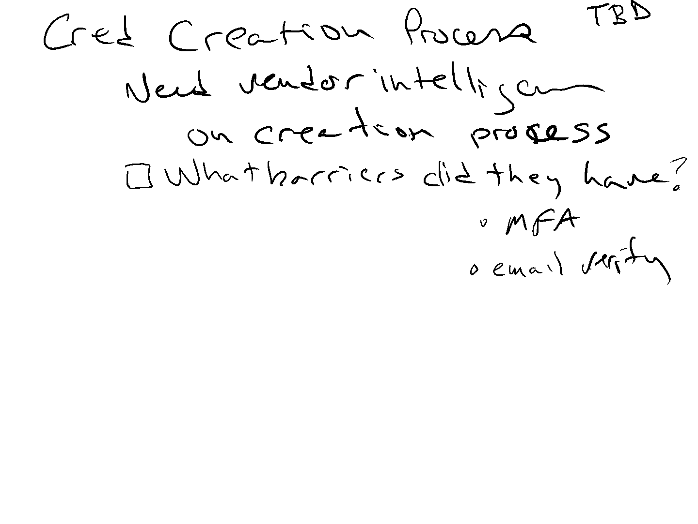

2 or 3 weeks after their go live. She says, now they're about 5 to 6 weeks. She said, she's starting to see her vendor clients starting to trend down. So she faster than she would expect. So she thinks positive.

She does think that it did help going in and doing some of this work, even though we were a little behind and didn't get it done as early as I would like. So it's great. soWe have the intake credential creation, which is sort of put a pin in it, umI think, than the next pieces.

And I don't know that there's anything to be detailed per se, but then there is resolution process that's from from that intake piece. When we found failures. I don't know if there's just that who does that, but I don't processor.

There needs to be a to me, it goes to a place. yeahIt goes to a queue. Yeah, because login failures, right? Happen, umwhere the credential doesn't work, we have new accounts that need to be validated.

To other process. You have inactive accounts that would have to be cleaned up. you knowI just outlines the the the three critical things that they're trying to attempt to do inside the log in. You. youWe want to push any of that anywhere.

right hey weWe can't change the address, because I need to submit a request. We have that information. Am I doing that? So like? umSo those would all be potential tickets or work that would have to be done and resolved to bring it to completion.

Do we um the moment? Are we looking at, if there's a situation where say there's a the accounts there we can successfully log into. But there isn't any place reaching out to the client or there's a client email for verification.

To me, once we go through thethis is my thought. Once we go through the queue that the info comes to us, if we need the client's help, then there's a few that goes to them. There's an external component that we can send it to the client for review, because they, in this queue, i'm envisioning we're going to have to like double check some work just to make sure, because maybe the website was down, or mhm they made some yeah the website is down, for example, with quit quack, which we learned a lot, which is probably why the the resolution rate was low.

The vet the client didn't give us website. soThey had to go and do a web search to try to find the log ins for every single one of these vendors. andThey were able to do it for most of the times. They were able to find it successfully log in and validate it.

So that can be a challenge where I don't know what the website is, or the vendor name that the client has got listed, doesn't match ours. I think the other part of it, too, as i've looked at, those particular cases, is at what point do we want do we just want the root the home page for the vendor? Or do you want to drill down to the navigation page, which is not necessarily because those things change quite a bit.

Yeah, and andand i've seen some really weird things that have been at the list of in the vcm of how far down. Yeah, so that's you that you figuring out how we're gonna hit the website, what do you want them grabbing right as if we are using technology? Right?

Exactly. Because it doesn't really take a whole lot of work. In most cases, i've seen some strange municipality websites that are very difficult to navigate. um there are someThat are regional based, right?

With weak energy will yeah ask you for. I will say i've been fairly surprised at how well this team is navigating around with little direction, like awesome. They log in and they're able to to verify and and find things.

And I what I haven't done and is I'm not Micro managing and spot checking, literally everything going sure. You said, you didn't shouldn't couldn't change the address. did can youDid you just not find like, I haven't gone to that level.

That's what stuck you with your feedback loop, too. so we yeahWe want to have some sort of quality sampling. MHMYes. You mean quality is a distant thought, wellbut I mean I was thinking about through those pieces there.

And there's a lot of that stuff we can great validation for like one of the things that I was seeing was just I was going to try to pull how many yeah urls there were just downloaded the whole list. And I noticed there's a lot of cases if you go into a cut and paste from a website Excel file, often it pastes the name of the website and then a link to it, which doesn't upload into bcm because there's no there's no yeah URL. It's just Duke Energy slash login.

And that oh that's what ends up getting uploaded into the system. So it's just there's like weird stuff like that that i've seen. But there's a lot of opportunity for validating, yeahbecause there's no validation in the parent system.

I think having you just saying that whole quality checking piece, we're going back to the people process and technology. We need an internal team to manage it like 100% getting a process stood up and trying to get it moving is what is one thing? Yeah, 100% not be the process owner.

I'm just saying 100% I mean if you want me to, that's why we have to talk about. Yeah. Exactly. So what I just think is we start to scale up. You're going to end up with an entire team that needs absolutely well to be managing all those, managing all of that, because things will be changing.

And I don't I think this is Todd and I have gone back. I don't know where the right place for that. This is a lot of vendor stuff, but there's a lot of client based stuff. Yeah, to me, it. So its like a good idea is where it can go.

A lot of it is on the intake, it's on the front, it's on implementation. So it does it live under that I don't know to a certain degree, but then there's a lot of real life stuff once it's live and doing well, right? Changes just happen.

So future state, somebody 18 needs to own this, even if it stays in abpo state, miss too much. YeahSo I just needed I needed a solution. We needed to get it. no noNo. andAnd I think that's I think that's an awesome awesome working because you have the the contact from the BPO and sort of moving those in that direction.

I think that's great. But I just think that the client contact is secondary to the process. andSo hopefully that client component we can shift into a portal. soMost of that is resolved through the natural normal course of business.

you knowIt's going to be like a digital managing all these pieces and parts, yeahbecause there's a lot of pieces and parts. Mhm. And all lead into each other. We have like 5 minutes before Andrew and I need to jump on that desk.

okaySo we have so so we we talked about the creation, thethe credential intake, the creation. We sort of kind of briefly touched just about resolution, although which is more of this queue. yepThere's a lot of detail.

And we have some of that documented MHM um is there any key elements from a technology? Perspectives? I think we need to pull in like either Becky or Lean. I don't remember who Dean said and start talking about.

I'm just looking at my notes, this chunkthis chunk of what Andrea is doing with premiere, what we havewhat we need and have her start putting it into technology sweep. Because I think the other part of the resolution piece, if you think of is is we have we have delivery failures. MHMThat is another cue of my opinion.

Do you wanna those cues would be separate or 100%? Yeah. To me, there's credential failures, there's delivery failures, a variety of failures. And we did map this a little bit differently piece. Theoretically, everything PDF into a bucket and get strapped in and connects that.

MHM Mhm andI'll pay closer attention to the general EMAIL communication that comes from Arcadia about various websites, just like that. Understand that. More. oh my godWhy do we need to talk about appeal?

I specifically told them you need appeal. They asked me first, then they went to you, and then they brought it back up in the multi tennis conversation today. And now they're throwing, like we want to talk through that to ease our client's impact.

There's no client impact. You need to do address changes with your haulers to a new po box. Full stop. That'sThey are not understanding that Andrew, Ken. So you and I are now in a meeting with them. Yay.

Sorry. So I think we need to come back to this piece and also scheduling, downloading and management pieces. And then yeah I feel like we spent most of our time talking about the the credential management, because that's like 2090%, we get that, right?

The other stuff should be fairly straightforward, right? um YeahI think so. And it also prevents some of that is future. That's a future state, right? If we can verify how to credential management, at least for the now, yeahand then

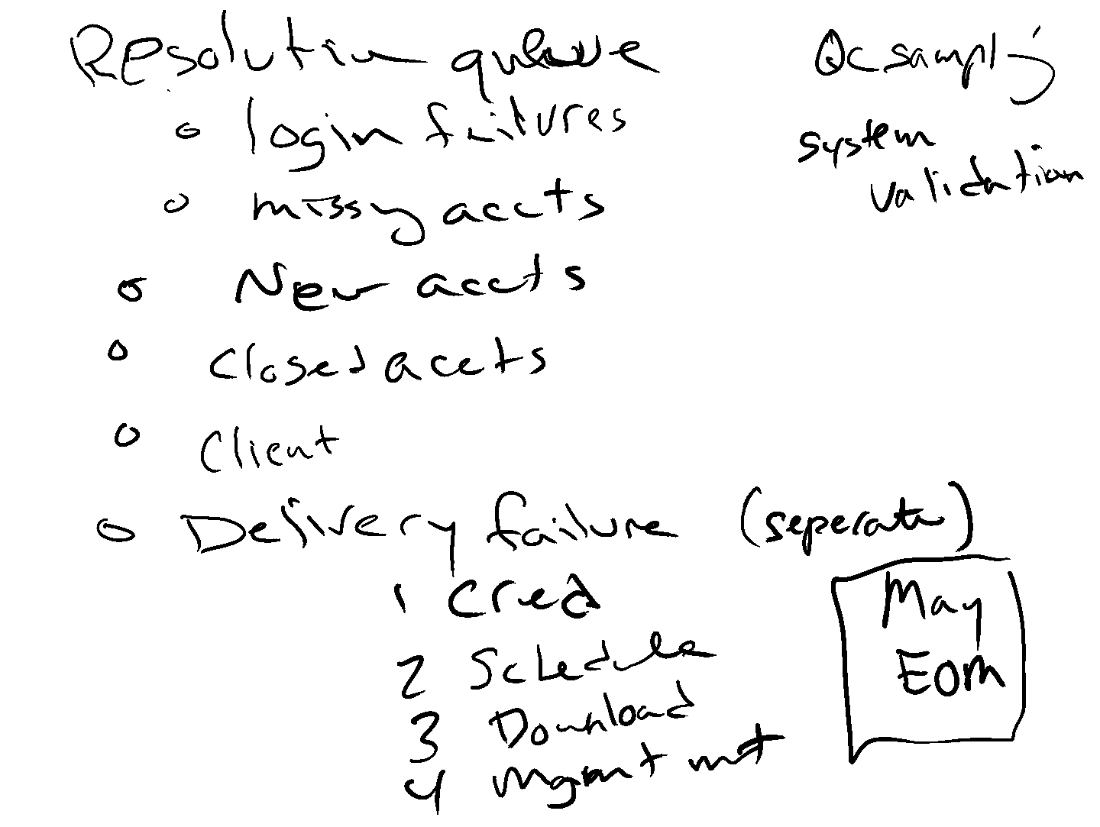

soMhm. But I do feel like there's more of an urgent need for some of the enrollment management with the lax aid, because that's that's basically what Miranda is. .